Sort command
Sort command is use to do the sorting using ASCII Keys by default

cat > employee.txt
1,Raj,12000
3,Ravi,16000
2,Mahesh,14000
5,John,19000
4,Lokesh,25000

$ sort employee.txt by asc order
1,Raj,12000
2,Mahesh,14000
3,Ravi,16000
4,Lokesh,25000
5,John,19000

$ sort -r employee.txt desc order
5,John,19000
4,Lokesh,25000
3,Ravi,16000
2,Mahesh,14000
1,Raj,12000

sort -r -k3 -t ',' employee.txt
-r revers order or descending orfer
-k3 3rd field
-t delimiter by default space

Unix File permission

In window OS file can be read or write mode
In Non window OS file can be read, write and execute code.

In OS types of user
Owner (U) file creator
Group (g) user in same group
Other (o) everyone or guest user

Permission symbol
Read r
Write w
Execute x

Providing the permission using symbolic mode
chmod u+x file provide execute mode
chmod u-x file remote execute mode permission

chmod u+w file provide write mode
chmod u-w file remote write mode permission

chmod u+r file provide read mode
chmod u-r file remote read mode permission

by default read and write mode permission

Provide the permission using numerical mode

7 - rwx
6 rw
5 rx
4 r
Owner
Group
Others
chmod 777 filename
chmod 755 filename
group and other people can read and execute but can’t change means can’t update.

Shell scripting : we can execute set of command with or without condition.

Git : Git is Version control system :

Version control system that records all changs which we do in file or folder inside a project develop using any language.

Local Version control : RCS : Revision control system : local machine
Centralized version control system : CVS or SVN : client and server
Server machine n number people connected.
Git is distributed sub version control tool use to source code management.
Local machine also contains repository as well as we can connect to remote repository provided by different vendor : Github, Gitlab aws, azure

Git and Github

How to make local folder as a repository

git init

then create the any file with any contents using GUI base or command prompt and in git terminal check the status
git status
git add filename.extension add the file from file system to stagging area
or
git add . all files and folder present in current directory
git commit -m “task done” it push you task to local repository.

if you get any error message about author details
git config --global user.name “Akash”
git config --global user.email “akash@gmail.com”

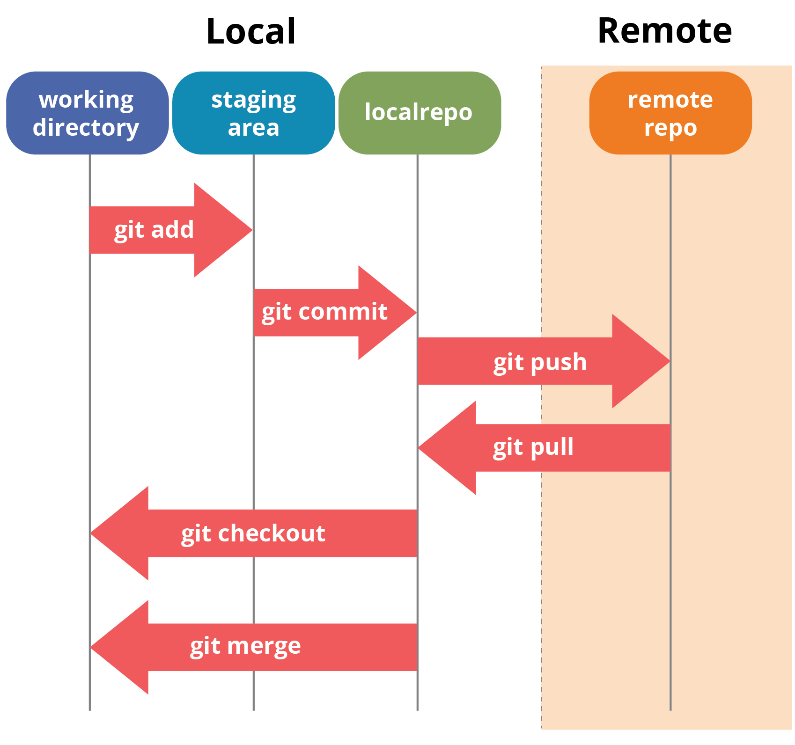

Git branch : git branch is like a pointer which hold more than one commit details.
By default git create default branch as master or main.

To view all branches present in current directory
git branch
creating new branch
git branch branchname
to switch one branch to another branch
git checkout branch_name

